**10 Steps to creating an R environment and running R-Studio**

1. Open ANACONDA Navigator
2. In Navigator, click the Environments tab, then click the Create button. The Create new environment dialog box appears.
3. In the Environment name field, type a descriptive name for your environment.

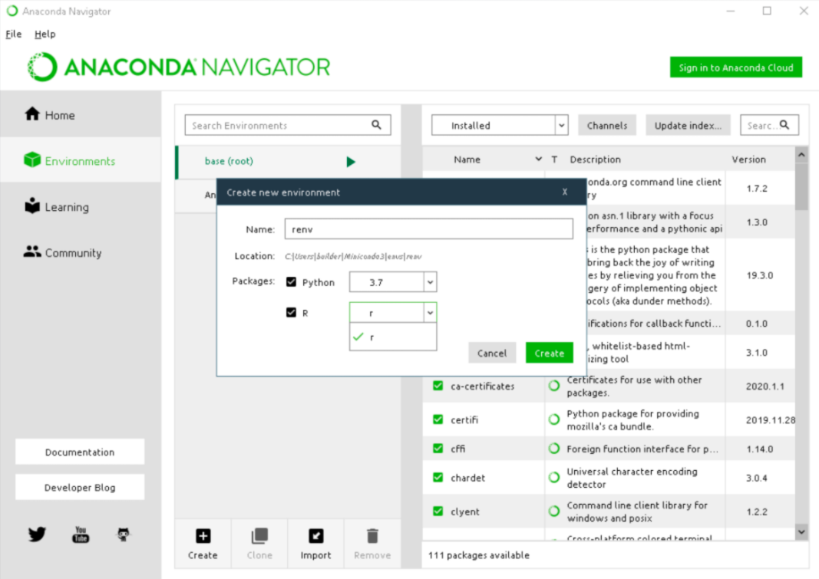

1. In the Packages list, select “R”.
2. On the drop-down menu, select r to install R with the packages r-base and r-essentials. For more information please see [Using R language with Anaconda](https://docs.anaconda.com/anaconda/user-guide/tasks/using-r-language/).
3. Click the Create button.
4. Navigator creates the new environment and activates it, as shown by the highlighted green bar. All actions take place in the active environment.

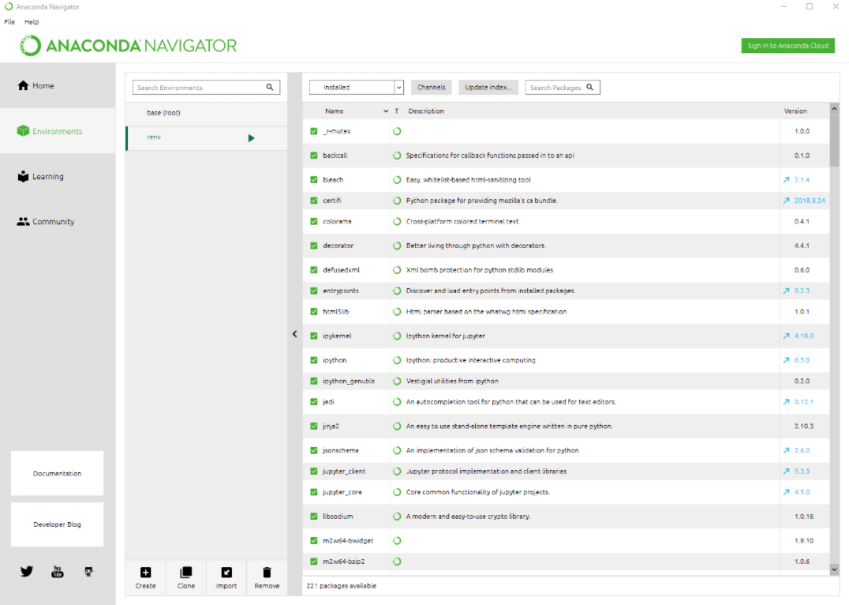

1. With the new environment active, click the Home button and then click the Install button on the RStudio application.

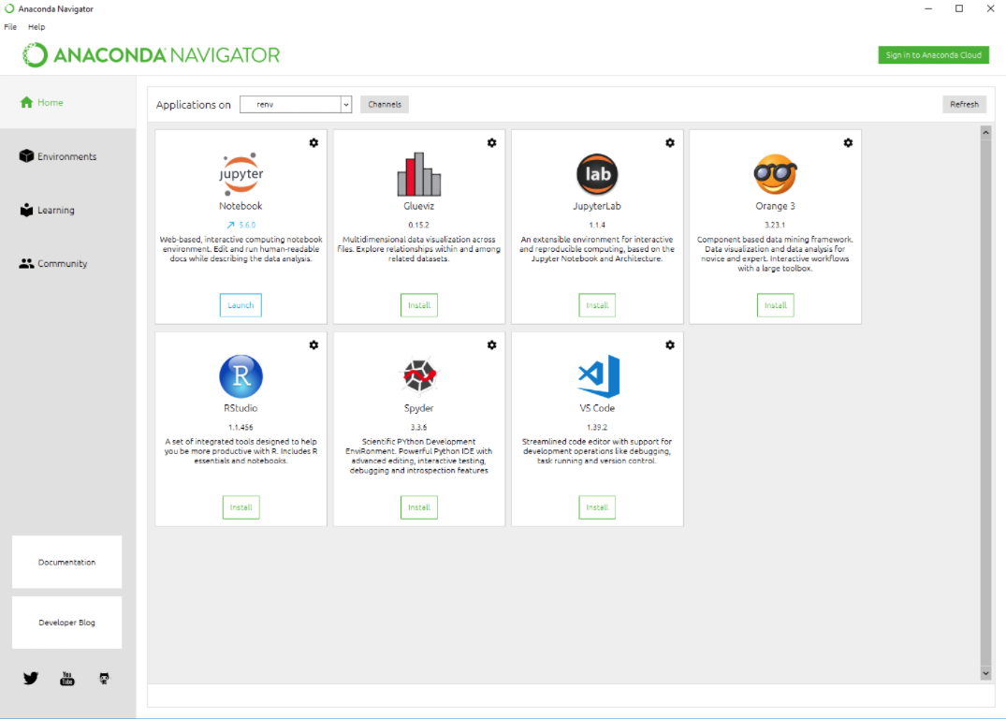

1. Click Launch to run RStudio from Navigator.

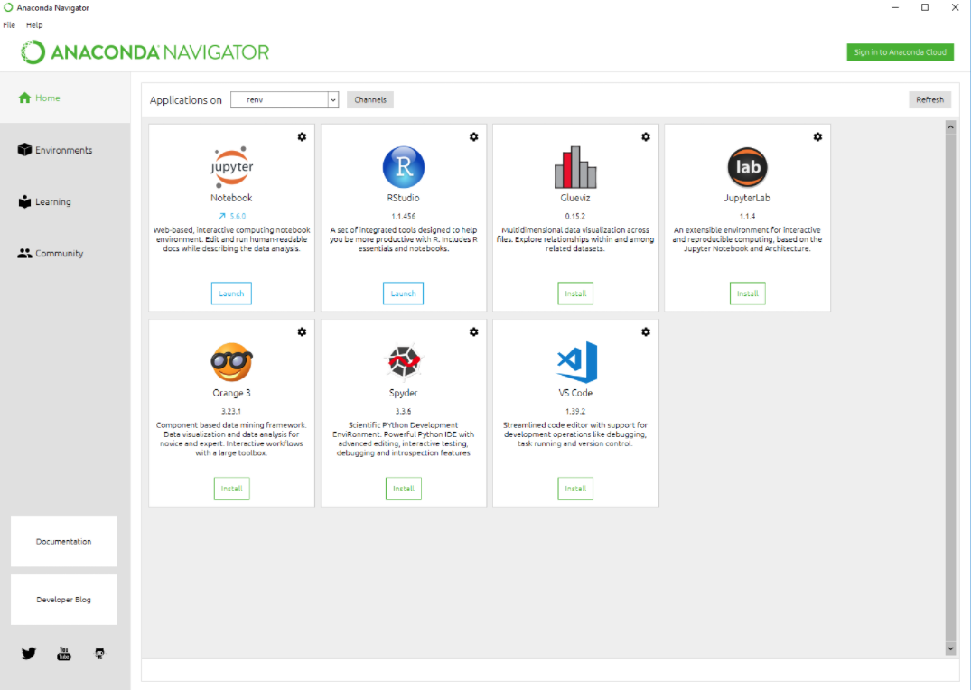

1. You will see RStudio running from Navigator.

